Experiment 6
Name: Kaushik Kaundal | UID: 24BAI70562
Branch: B.E. CSE (AIML) | Section: 24AIT_KRG-G1
Semester: 4 | Date of Performance: 13.03.2026
Subject Name: Database Management System | Subject Code: 24CSH-298

AIM: To understand the concept and working of cursors in PL/SQL for row-by-row data processing, and to analyze how implicit cursors, explicit cursors, and cursor attributes are used to implement business logic on multiple rows in a database table.
OBJECTIVES:
- To implement and analyze the use of implicit cursors, explicit cursors, and cursor attributes for processing multiple rows from a database table and applying business logic effectively.
SOFTWARE REQUIREMENTS:
- Database Management System:
  - PostgreSQL Database
- Database Administration Tool / Client Tool:
  - pgAdmin

PRACTICAL/EXPERIMENT STEPS:
- An employees table was created in the Oracle database with columns such as emp_id, emp_name, and emp_sal to store employee details.
- Sample employee records were inserted into the table to provide data for testing cursor operations.
- The concept of implicit cursors was studied to understand how Oracle automatically handles DML operations like UPDATE.
- A PL/SQL block using an implicit cursor was written to update employee salary and verify execution using SQL%FOUND and SQL%ROWCOUNT.
- The concept of explicit cursors was explored to process multiple rows returned by a SELECT query.
- A PL/SQL program using an explicit cursor was written to fetch employee records one by one and apply business logic.
- The programs were executed in Oracle FreeSQL, and the output results were verified for correctness.

PROCEDURE:
- The Oracle FreeSQL environment was opened to access the database.
- A new employees table was created with fields such as emp_id, emp_name, and emp_sal.

- Sample employee records were inserted into the table using INSERT statements.
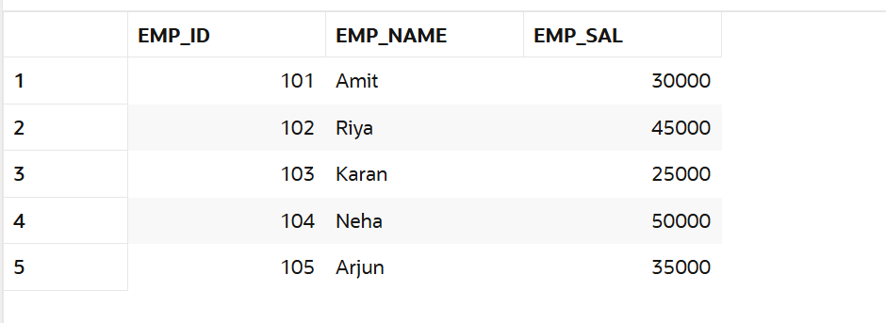
- A PL/SQL block using an implicit cursor was written to update employee salary and check execution status using SQL%FOUND and SQL%ROWCOUNT.
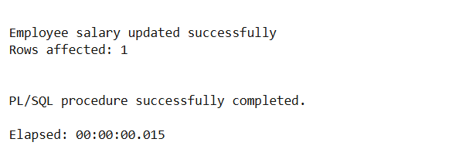
- An explicit cursor was declared to retrieve multiple employee records from the table.
- The cursor was opened, and records were fetched one by one using a LOOP structure, and business logic was applied.
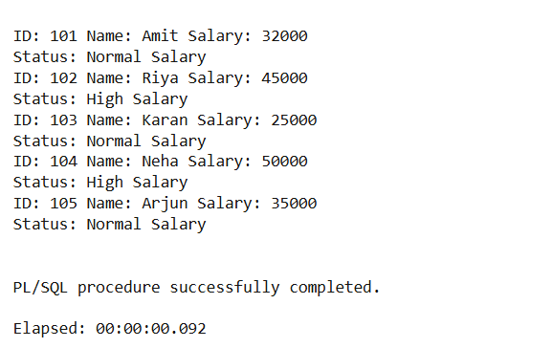
- The cursor was closed after processing all records, and the output was observed and recorded.
CODE:
CREATE TABLE employees (
emp_id NUMBER PRIMARY KEY,
emp_name VARCHAR2(50),
emp_sal NUMBER
);

INSERT INTO employees VALUES (101, 'Amit', 30000);
INSERT INTO employees VALUES (102, 'Riya', 45000);
INSERT INTO employees VALUES (103, 'Karan', 25000);
INSERT INTO employees VALUES (104, 'Neha', 50000);
INSERT INTO employees VALUES (105, 'Arjun', 35000);

COMMIT;

DECLARE
v_emp_id employees.emp_id%TYPE := 101;
v_new_sal employees.emp_sal%TYPE := 32000;
BEGIN
UPDATE employees
SET emp_sal = v_new_sal
WHERE emp_id = v_emp_id;

IF SQL%FOUND THEN
DBMS_OUTPUT.PUT_LINE('Employee salary updated successfully');
ELSE
DBMS_OUTPUT.PUT_LINE('Employee not found');
END IF;

DBMS_OUTPUT.PUT_LINE('Rows affected: ' || SQL%ROWCOUNT);
END;
/
DECLARE
CURSOR emp_cursor IS
SELECT emp_id, emp_name, emp_sal FROM employees;

v_id employees.emp_id%TYPE;
v_name employees.emp_name%TYPE;
v_sal employees.emp_sal%TYPE;
BEGIN
OPEN emp_cursor;

LOOP
FETCH emp_cursor INTO v_id, v_name, v_sal;
EXIT WHEN emp_cursor%NOTFOUND;

DBMS_OUTPUT.PUT_LINE('ID: ' || v_id ||
' Name: ' || v_name ||
' Salary: ' || v_sal);

IF v_sal > 40000 THEN
DBMS_OUTPUT.PUT_LINE('Status: High Salary');
ELSE
DBMS_OUTPUT.PUT_LINE('Status: Normal Salary');
END IF;

END LOOP;

CLOSE emp_cursor;
END;
/

I/O ANALYSIS:
- Implicit Cursor Output

Displays messages indicating whether the employee salary was successfully updated and shows the number of rows affected using SQL%FOUND and SQL%ROWCOUNT.


- Explicit Cursor Output

Displays employee details (ID, Name, Salary) for each record fetched from the table.


- Business Logic Result
Shows classification of employees based on salary (e.g., “High Salary” or “Normal Salary”) for each row processed.
LEARNING OUTCOMES:
- Understood the role of cursors in PL/SQL for handling multi-row query results.
- Differentiated between implicit cursors and explicit cursors.
- Used cursor attributes such as %FOUND, %NOTFOUND, %ROWCOUNT.
- Developed PL/SQL programs that process database records row by row.
- Applied cursor-based logic to real-world business scenarios.

